EAACK—A Secure Intrusion-Detection
System for MANETs

Abstract

The migration to wireless network from wired network has been a global trend in the past few decades. The mobility and scalability brought by wireless network made it possible in many applications. Among all the contemporary wireless networks, Mobile Ad hoc NETwork (MANET) is one of the most important and unique applications. On the contrary to traditional network architecture, MANET does not require a fixed network infrastructure; every single node works as both a transmitter and a receiver. Nodes communicate directly with each other when they are both within the same communication range. Otherwise, they rely on their neighbors to relay messages. The self-configuring ability of nodes inMANETmade it popular among criticalmission applications like military use or emergency recovery. However, the open medium and wide distribution of nodes make MANET vulnerable to malicious attackers. In this case, it is crucial to develop efficient intrusion-detection mechanisms to protect MANET from attacks. With the improvements of the technology and cut in hardware costs, we are witnessing a current trend of expanding MANETs into industrial applications. To adjust to such trend, we strongly believe that it is vital to address its potential security issues. In this paper, we propose and implement a new intrusion-detection system named Enhanced Adaptive ACKnowledgment (EAACK) specially designed for MANETs. Compared to contemporary approaches, EAACK demonstrates higher malicious- behavior-detection rates in certain circumstances while does not greatly affect the network performances.

Existing System
Mobile Ad hoc NETwork (MANET) is a collection of mobile nodes equipped with both a wireless transmitter and a receiver that communicate with each other via bidirectional wireless links either directly or indirectly. Industrial remote access and control via wireless networks are
becoming more and more popular these days. One of the major advantages of wireless networks is its ability to allow data communication between different parties and still maintain their mobility. However, this communication is limited to the range of transmitters. This means that two nodes cannot communicate with each other when the distance between the two nodes is beyond the communication range of their own. MANET solves this problem by allowing intermediate parties to relay data transmissions. This is achieved by dividing MANET into two types of networks, namely, single-hop and multihop. In a single-hop network, all nodes within the same radio range communicate directly with each other. On the other hand, in a multihop network, nodes rely on other intermediate nodes to transmit if the destination node is out of their radio range. In contrary to the traditional wireless network, MANET has a decentralized network infrastructure.

Disadvantages

- The configuration and quick deployment make MANET ready to be used in emergency circumstances where an infrastructure is unavailable or unfeasible to install in scenarios like natural or human-induced disasters, military conflicts, and medical emergency situations.
- The fact that MANET is popular among critical mission applications, network security is of vital importance.
- The open medium and remote distribution of MANET make it vulnerable to various types of attacks. For example, due to the nodes’ lack of physical protection, malicious attackers can easily capture and compromise nodes to achieve attacks.

Proposed System
The MRA scheme is designed to resolve the weakness of Watchdog when it fails to detect misbehaving nodes with the presence of false misbehavior report. The false misbehavior report can be generated by malicious attackers to falsely report innocent nodes as malicious. This attack can be lethal to the entire network when the attackers break down sufficient nodes and thus cause a network division. The core of MRA scheme is to authenticate whether the destination node has received the reported missing packet through a different route. the source route broadcasts an RREQ message to all the neighbors within its communication range. Upon receiving this RREQ message, each neighbor appends their addresses to the message and broadcasts this new message to their neighbors. If any node receives the same RREQ message more than once, it ignores it. If a failed node is detected, which generally indicates a broken link in flat routing protocols like DSR, a RERR message is sent to the source node. When the RREQ message arrives to its final destination node, the destination node initiates an RREP message and sends this message back to the source node by reversing the route in the RREQ message.

Advantages
- The terms of computational complexity and memory consumption, we did research on popular mobile sensors. According to our research, one of themost popular sensor nodes in themarket is Tmote Sky.
- The second scenario, we set all malicious nodes to send out false misbehavior report to the source node whenever it is possible. This scenario setting is designed to test the IDS’s performance under the false misbehavior report.
- The introduction of MRA scheme mainly contributes to this performance. EAACK is the only scheme that is capable of detecting false misbehavior report.

Module
- IDS in MANETs
- Watchdog
- TWOACK
- Digital Signature
- Simulation Methodologies
- Routing overhead

Module Description

IDS in MANETs
The assume that other nodes always cooperate with each other to relay data. This assumption
leaves the attackers with the opportunities to achieve significant impact on the network with just one or two compromised nodes. To address this problem, an IDS should be added to enhance the security level of MANETs. If MANET can detect the attackers as soon as they enter the network, we will be able to completely eliminate the potential damages caused by compromised nodes at the first time. IDSs usually act as the second layer in MANETs, and they are a great complement
to existing proactive approaches. Anantvalee and Wu presented a very thorough survey on contemporary IDSs in MANETs. In this section, we mainly describe three existing approaches, namely, Watchdog TWOACK and Adaptive Acknowledgment.

Watchdog
The proposed a scheme named Watchdog that aims to improve the throughput of network with the presence of malicious nodes. In fact, the Watchdog scheme is consisted of two parts, namely, Watchdog and Path rater. Watchdog serves as IDS for MANETs. It is responsible for detecting malicious node misbehaviors in the network. Watchdog detects malicious misbehaviors by promiscuously listening to its next hop’s transmission. If a Watchdog node overhears that its next node fails to forward the packet within a certain period of time, it increases its failure counter. Whenever a node’s failure counter exceeds a predefined threshold, the Watchdog node reports it as misbehaving. In this case, the Path rater cooperates with the routing protocols to avoid the reported nodes in future transmission.

TWOACK
The six weaknesses of the Watchdog scheme, many researchers proposed new approaches to solve these issues. TWOACK proposed is one of the most important approaches among them. On the contrary to many other schemes, TWOACK is neither an enhancement nor watchdog-based scheme. Aiming to resolve the receiver collision and limited transmission power problems
of Watchdog, TWOACK detects misbehaving links by acknowledging every data packet transmitted.
Digital Signature
Digital signatures have always been an integral part of cryptography in history. Cryptography is the study of mathematical techniques related to aspects of information security such as confidentiality, data integrity, entity authentication, and data origin authentication. The development of cryptography technique has a long and fascinating history. The pursuit of secure communication has been conducted by human being since 4000 years ago in Egypt, according. Such development dramatically accelerated since the World War II, which some believe is largely due to the globalization process.

Simulation Methodologies
The better investigate the performance of EAACK under different types of attacks, we propose three scenario settings to simulate different types of misbehaviors or attacks.

Routing overhead
The RO defines the ratio of the amount of routing-related transmissions during the simulation; the source route broadcasts an RREQ message to all the neighbors within its communication range. Upon receiving this RREQ message, each neighbor appends their addresses to the message and broadcasts this new message to their neighbors. If any node receives the same RREQ message more than once, it ignores it. If a failed node is detected, which generally indicates a broken link in flat routing protocols like DSR, a RERR message is sent to the source node. When the RREQ message arrives to its final destination node, the destination node initiates an RREP message and sends this message back to the source node by reversing the route in the RREQ message.

Flow Chart
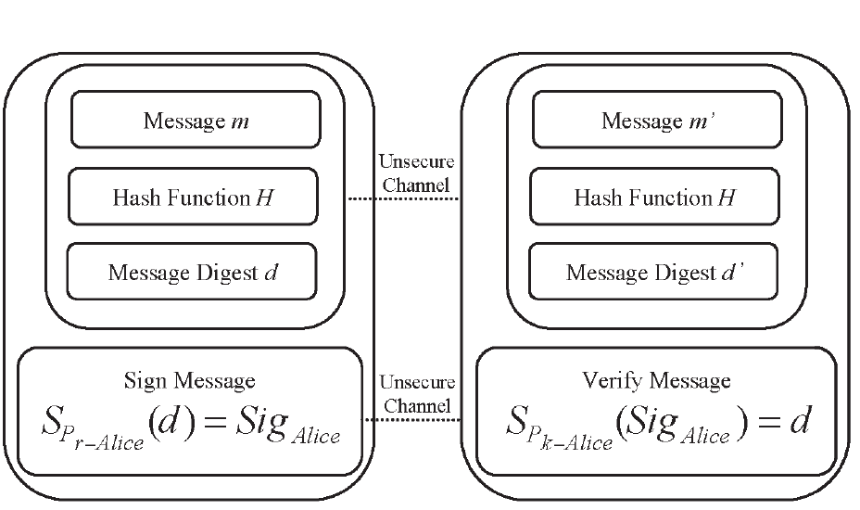

CONCLUSION
Packet-dropping attack has always been a major threat to the security in MANETs. In this research paper, we have proposed a novel IDS named EAACK protocol specially designed for MANETs and compared it against other popular mechanisms in different scenarios through simulations. The results demonstrated positive performances against Watchdog, TWOACK, and AACK in the cases of receiver collision, limited transmission power, and false misbehavior report. Furthermore, in an effort to prevent the attackers from initiating forged acknowledgment attacks, we extended our research to incorporate digital signature in our proposed scheme. Although it generates more ROs in some cases, as demonstrated in our experiment, it can vastly improve the network’s PDR when the attackers are smart enough to forge acknowledgment packets.We think that this tradeoff is worthwhile when network security is the top priority. In order to seek the optimal DSAs in MANETs, we implemented both DSA and RSA schemes in our simulation. Eventually, we arrived to the conclusion that the DSA scheme is more suitable to be implemented in MANETs.

REFERENCES

[1] K. Al Agha, M.-H. Bertin, T. Dang, A. Guitton, P. Minet, T. Val, and J.-B. Viollet, “Which wireless technology for industrial wireless sensor networks? The development of OCARI technol,” IEEE Trans. Ind. Electron., vol. 56, no. 10, pp. 4266–4278, Oct. 2009.

[2] R. Akbani, T. Korkmaz, and G. V. S. Raju, “Mobile Ad hoc Network Security,” in Lecture Notes in Electrical Engineering, vol. 127. New York: Springer-Verlag, 2012, pp. 659–666.

[3] R. H. Akbani, S. Patel, and D. C. Jinwala, “DoS attacks in mobile ad hoc networks: A survey,” in Proc. 2nd Int. Meeting ACCT, Rohtak, Haryana, India, 2012, pp. 535–541.

[4] T. Anantvalee and J. Wu, “A Survey on Intrusion Detection in Mobile Ad Hoc Networks,” in Wireless/Mobile Security. New York: Springer- Verlag, 2008.

[5] L. Buttyan and J. P. Hubaux, Security and Cooperation in Wireless Networks. Cambridge, U.K.: Cambridge Univ. Press, Aug. 2007.

[6] D. Dondi, A. Bertacchini, D. Brunelli, L. Larcher, and L. Benini, “Modeling and optimization of a solar energy harvester system for self-powered wireless sensor networks,” IEEE Trans. Ind. Electron., vol. 55, no. 7, pp. 2759–2766, Jul. 2008.

[7] V. C. Gungor and G. P. Hancke, “Industrial wireless sensor networks: Challenges, design principles, and technical approach,” IEEE Trans. Ind. Electron., vol. 56, no. 10, pp. 4258–4265, Oct. 2009.

[8] Y. Hu, D. Johnson, and A. Perrig, “SEAD: Secure efficient distance vector routing for mobile wireless ad hoc networks,” in Proc. 4th IEEEWorkshop Mobile Comput. Syst. Appl., 2002, pp. 3–13.

